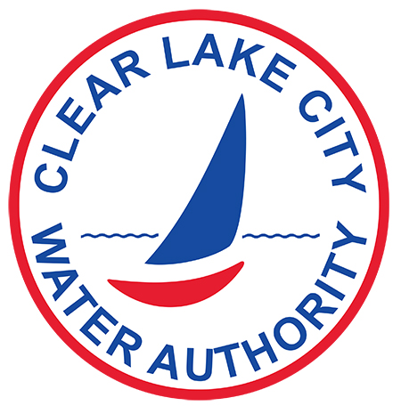

FLOOD STUDY SURVEY

- Name: _____________________________________________________________________________

- Property Address: ____________________________________________________________________

- Home elevation: _____________________________________________________________________

- Flood water height in your home: _______________________________________________________

___________________________________________________________________________________

- Please describe the cause of the flood water (street, back yard, roof, bayou, sewer utility line, other):

___________________________________________________________________________________

- Date water entered the home? _________________________________________________________

- Time water entered the home? _________________________________________________________

- Date water receded? _________________________________________________________________

- Time water receded? _________________________________________________________________

- Has your home previously flooded? If so, please explain including water height, dates, and times.

____________________________________________________________________________________

____________________________________________________________________________________

- May we call or email you with any additional questions? Yes ________ No _________

- Phone Number: ________________________ Email: ________________________________________

- Additional comments: _________________________________________________________________

____________________________________________________________________________________

____________________________________________________________________________________

CLCWA Board of Directors and Staff sincerely appreciate your cooperation and look forward
to receiving your responses. Please return the survey by mail, email, or fax to our office.

MAIL: CLCWA EMAIL: n.andrus@clcwa.org FAX: 281-488-6644
900 Bay Area Blvd.
Houston, TX 77058

